FSE Final SBA – WEBAPI and ANGULAR Project

1. Built User interface (UI) using Angular.

**Technical Spec for front end layer:** Angular,Bootstrap,CSS,HTML, JavaScript

Steps involved in installing Angular CLI:

* npm install -g @angular/cli
* ng new ProjectManagerUI
* cd ProjectManagerUI
* ng serve –open

1. Below is the screen of Angular code compiled and executed successfully

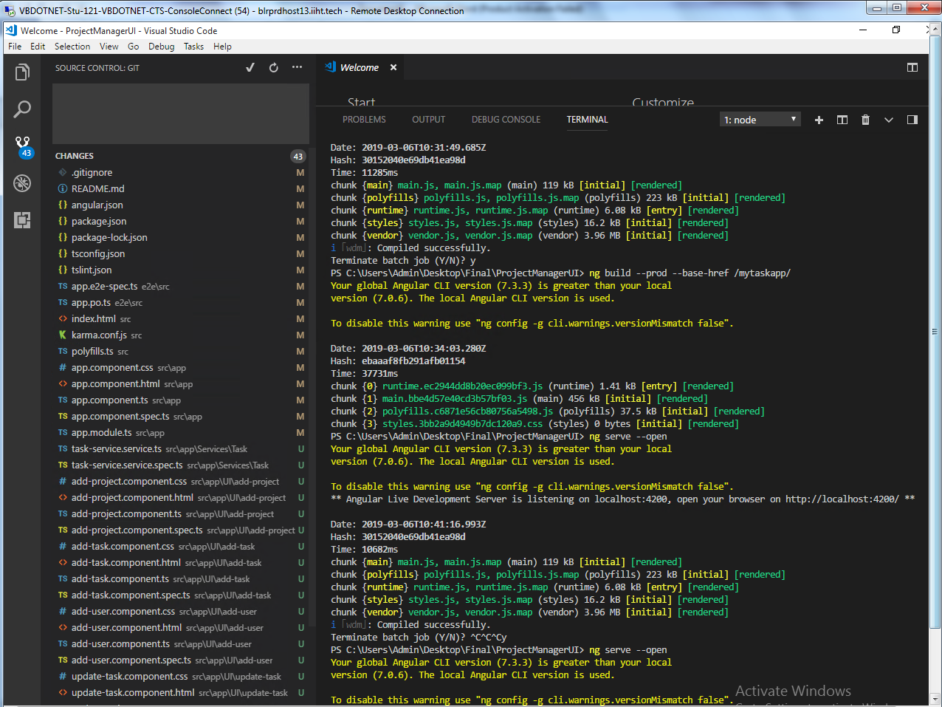

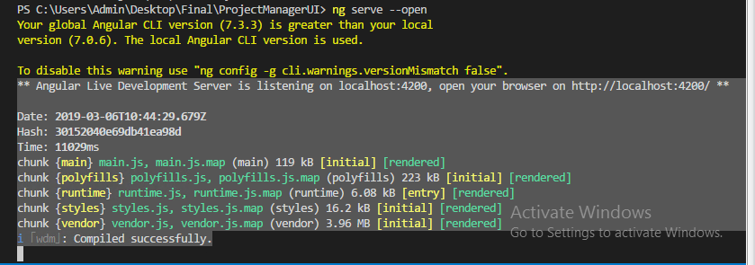

1. Please refer below output of the above angular code executed in browser

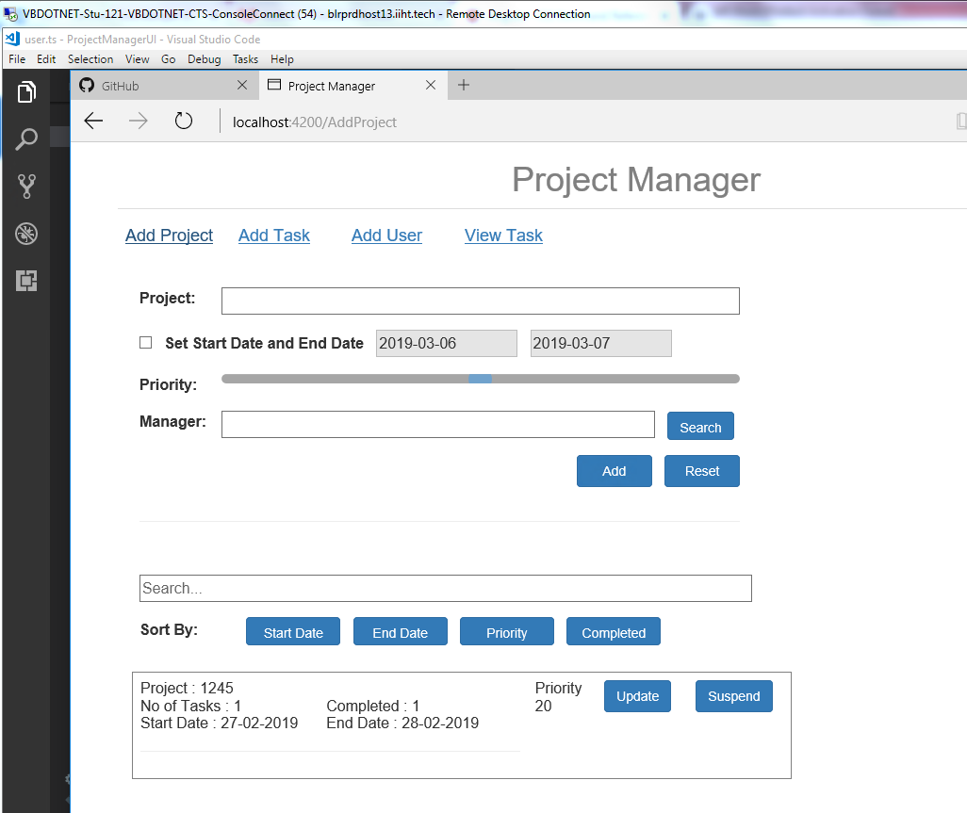

1. Various actions are allowed in UI are ADDPROJECT, ADDTASK, ADDUSER, VIEWTASK and its respective screen prints are listed below.

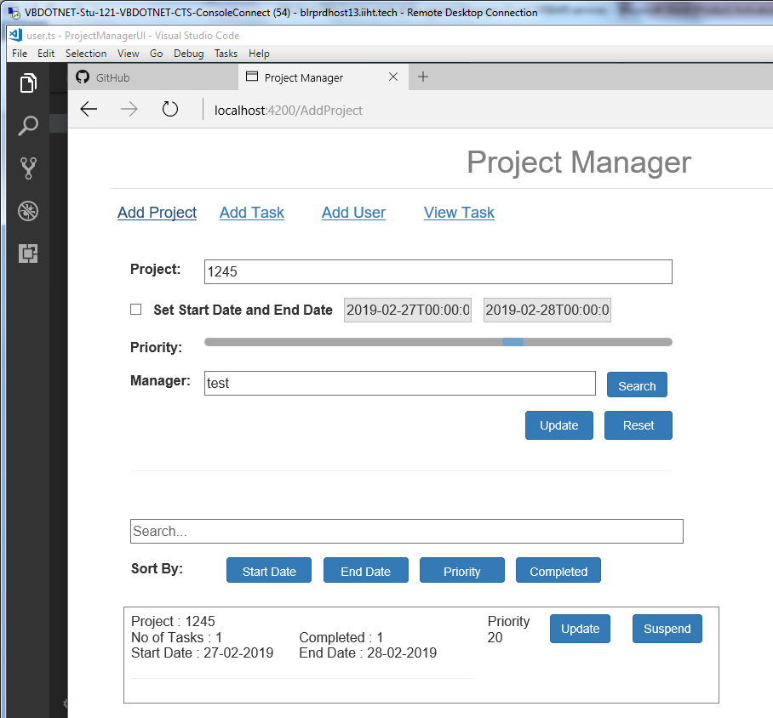

ADDTASK and UPDATE TASK:

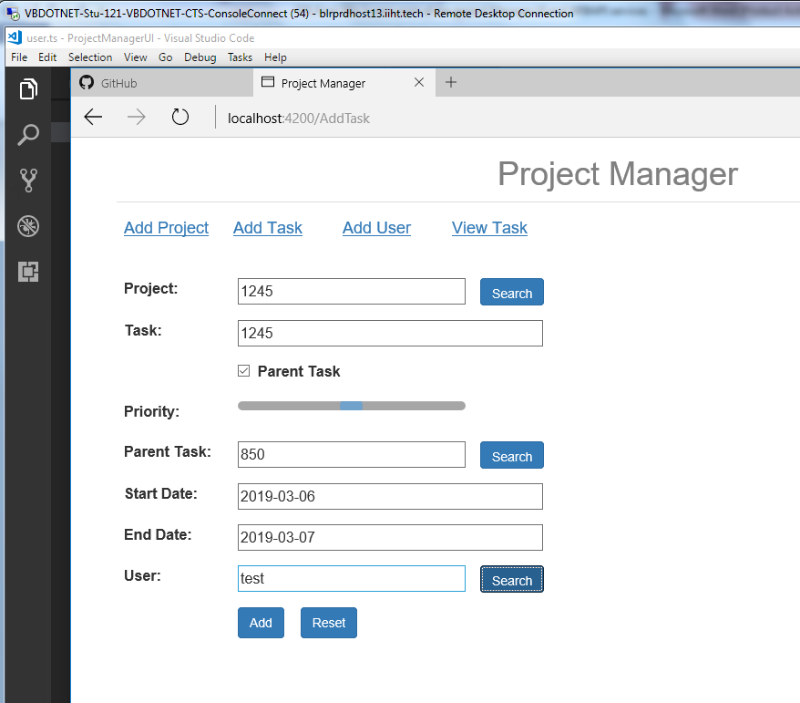

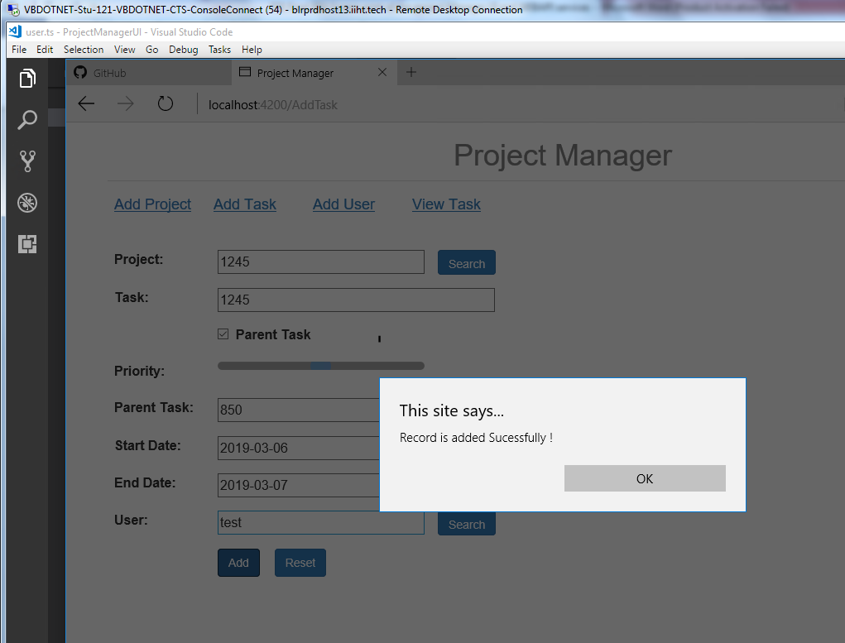

**ADDUSER and UPATE USER:**

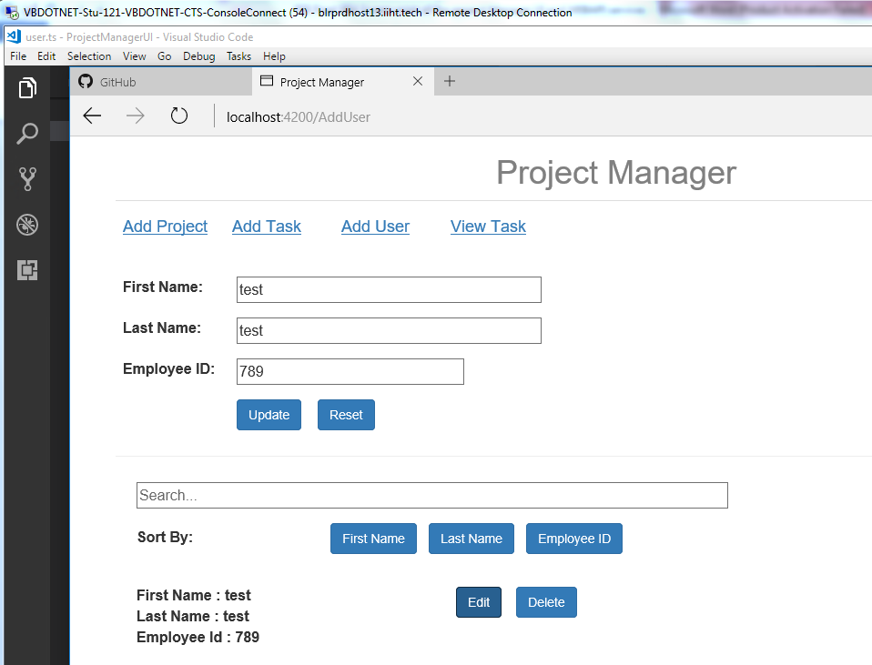

**View Task:**

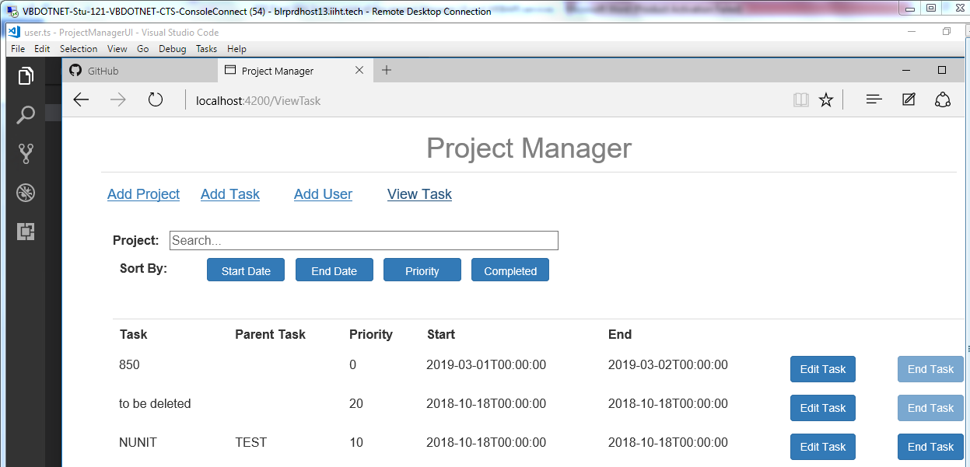

**UPDATE TASK:**

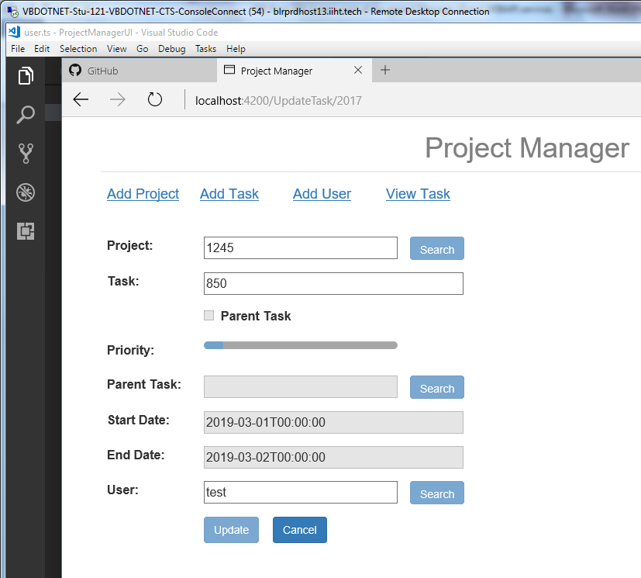

**SORT BY:**

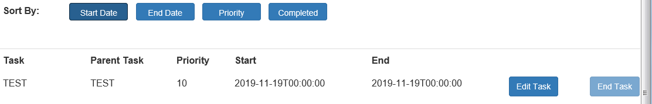

**SEARCH :**

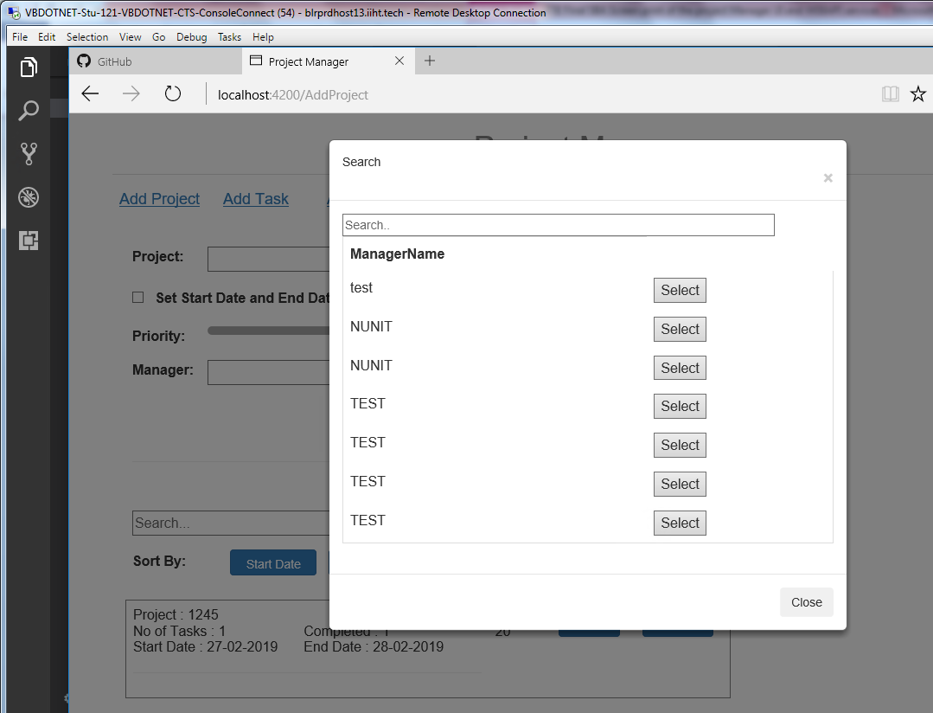

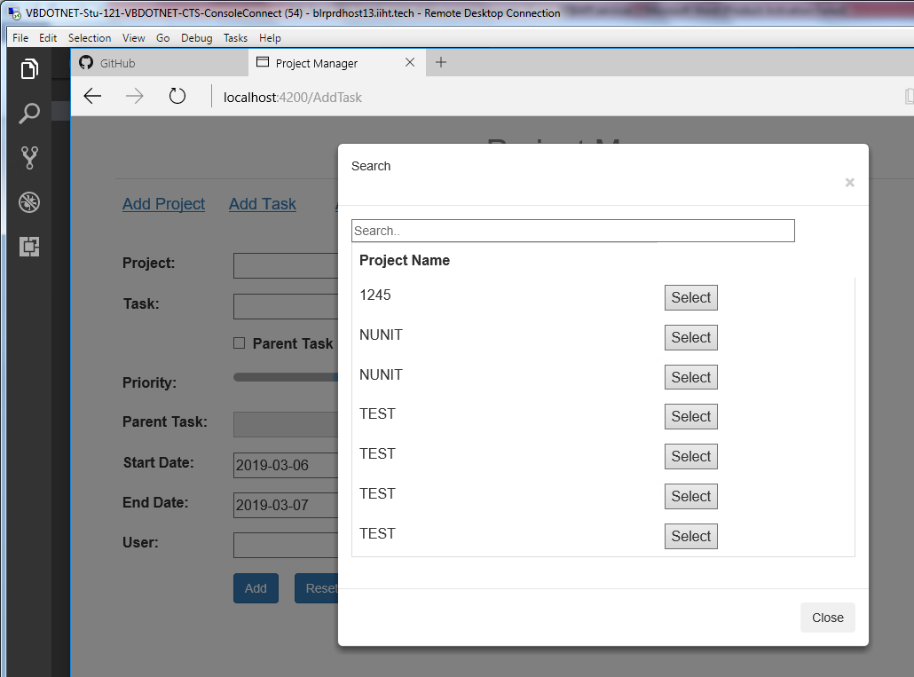

**USERNAME search:**

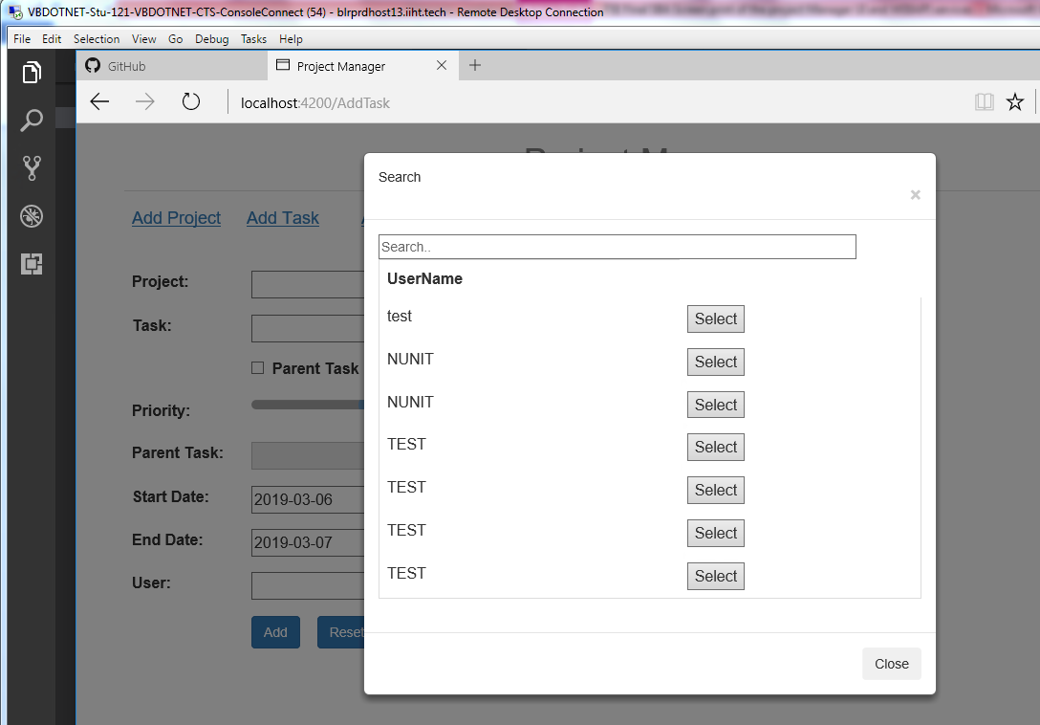

**Search:**

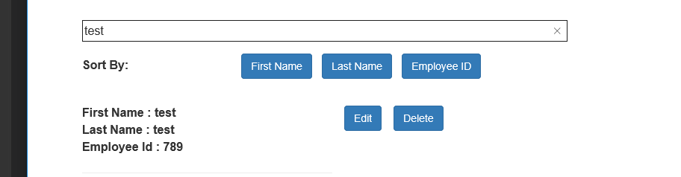

**Testing:**

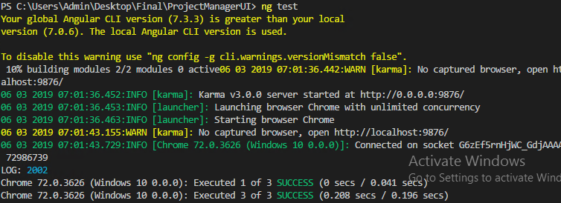

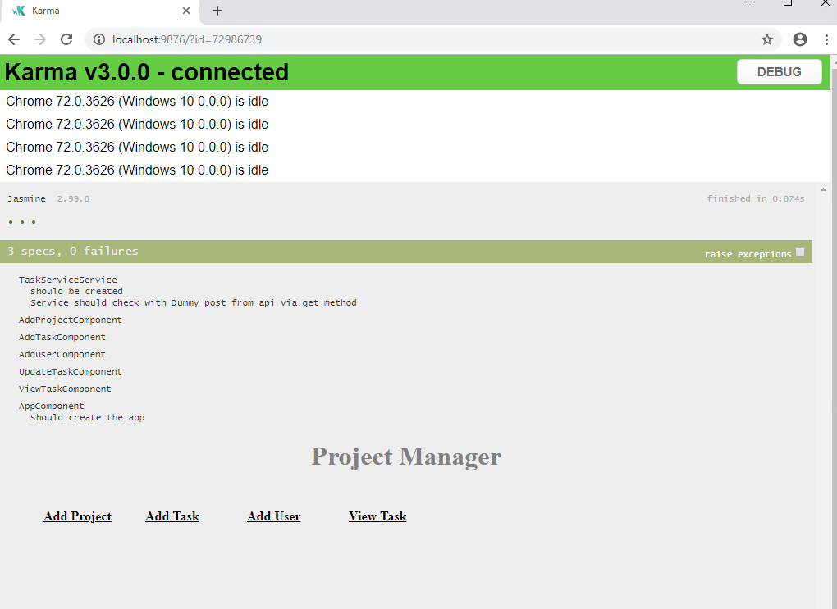

**Webapi**

Middle Tier Layer:

Technology: .NET – Framework and Webapi

Database & Integration Layer:

Entity Framework and Microsoft sql server

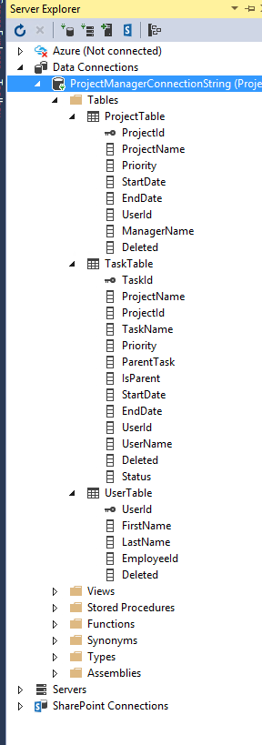

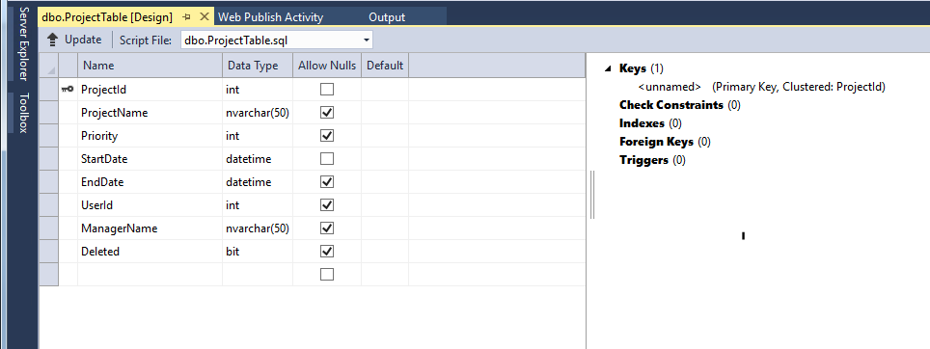

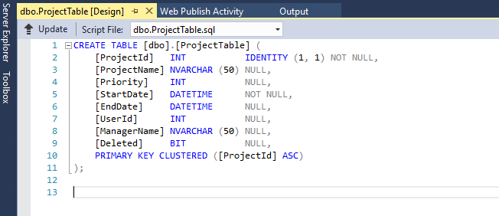

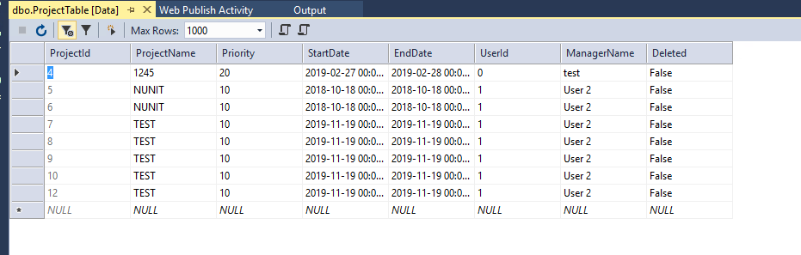

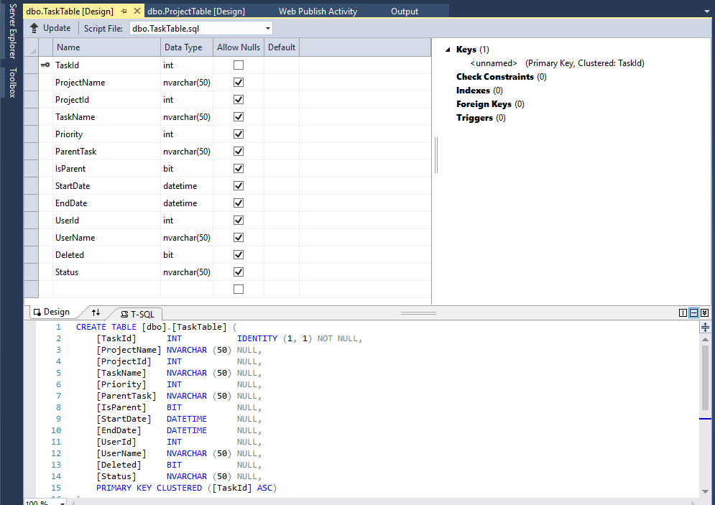

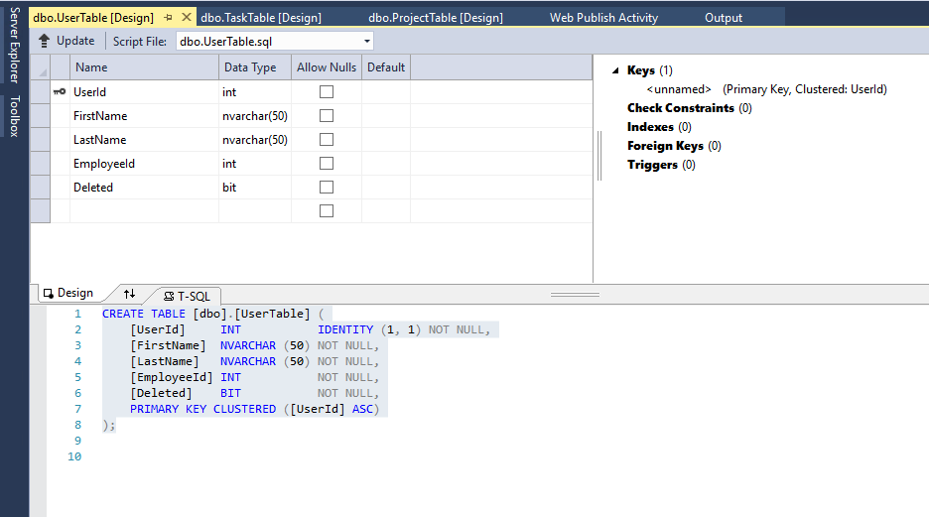

Webapi solution has been constructed with three different layer such as Bussiness, Data, entity layers and each has its different action method purpose.

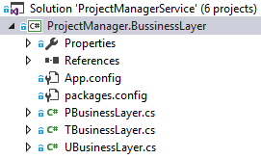

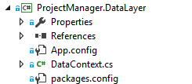

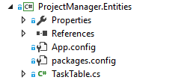

Project Solutions:

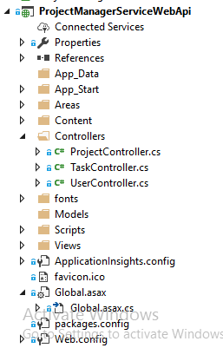

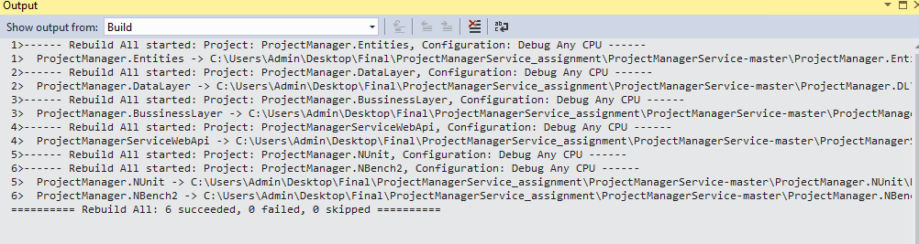

**Webapi Host in local server:**

Getproject Summary:

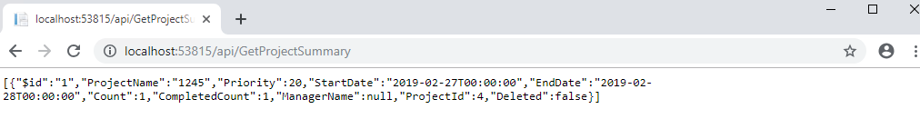

GetAllProjects:

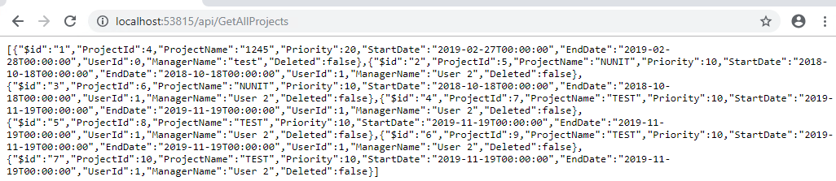

**Getalltask:**

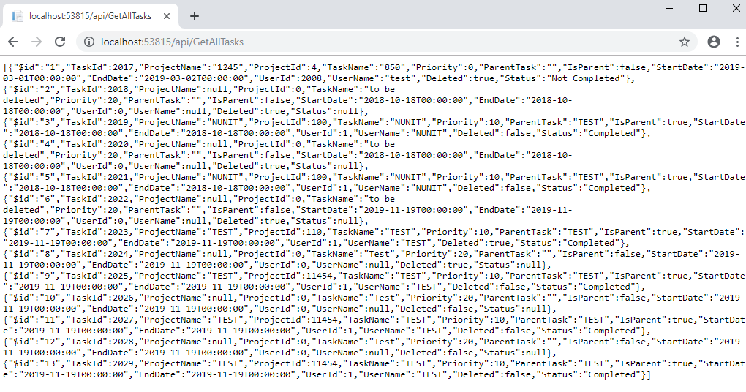

**Getallusers:**

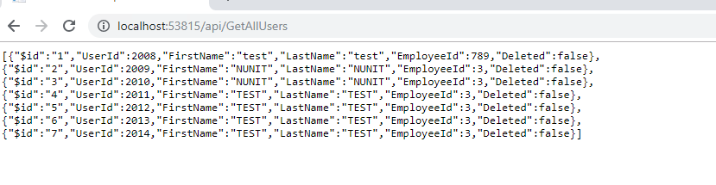

**GetUsersummary:**

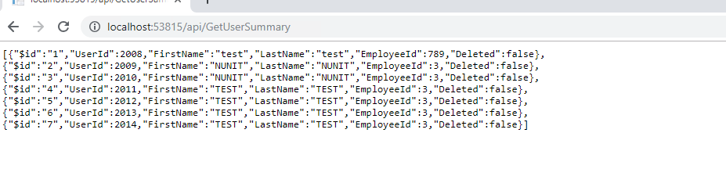

**Unit testing:**

I have included the test result of NBench and NUnit for testing purpose and respective solutions are as follow as:

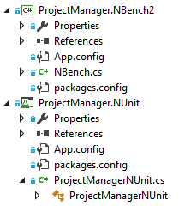

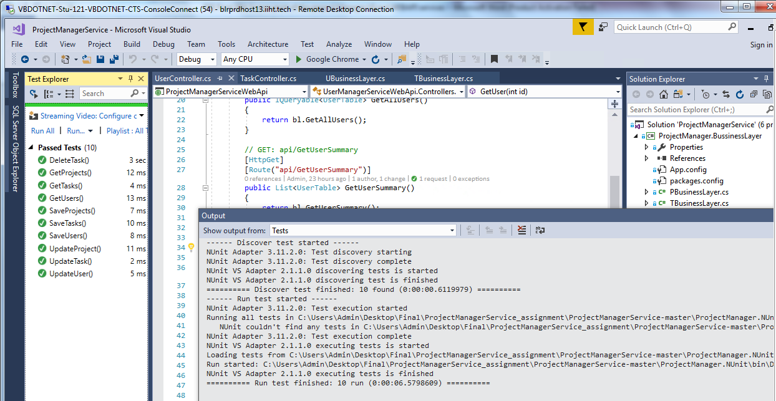

**Publish the code**

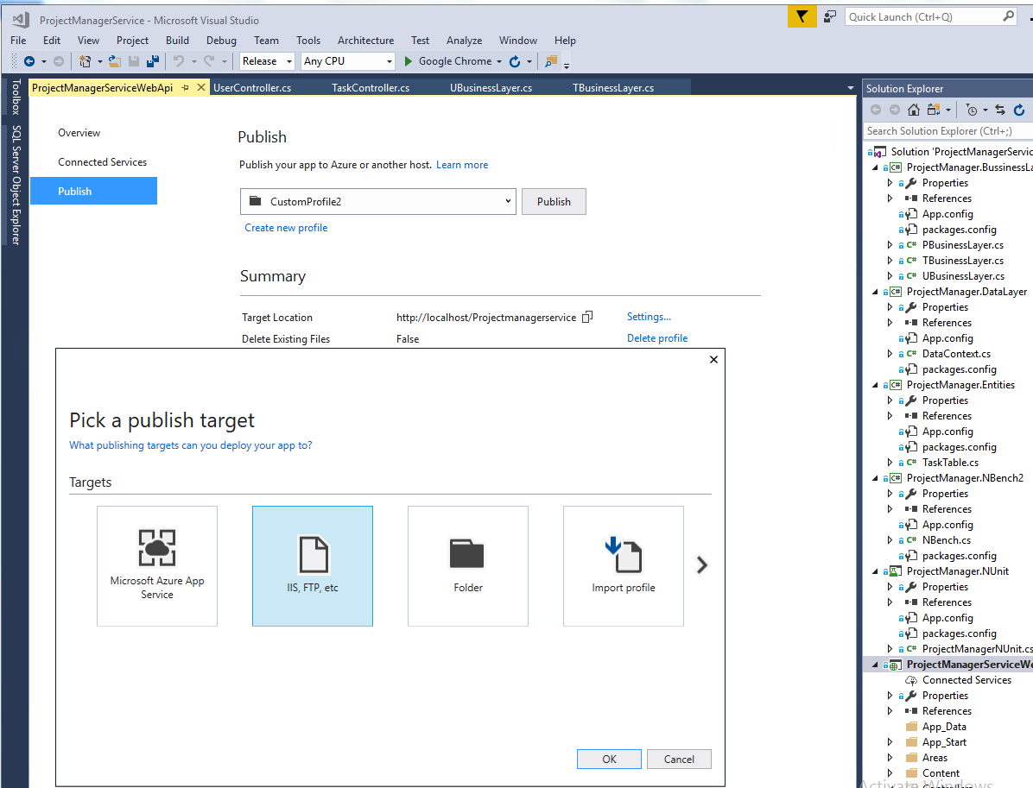

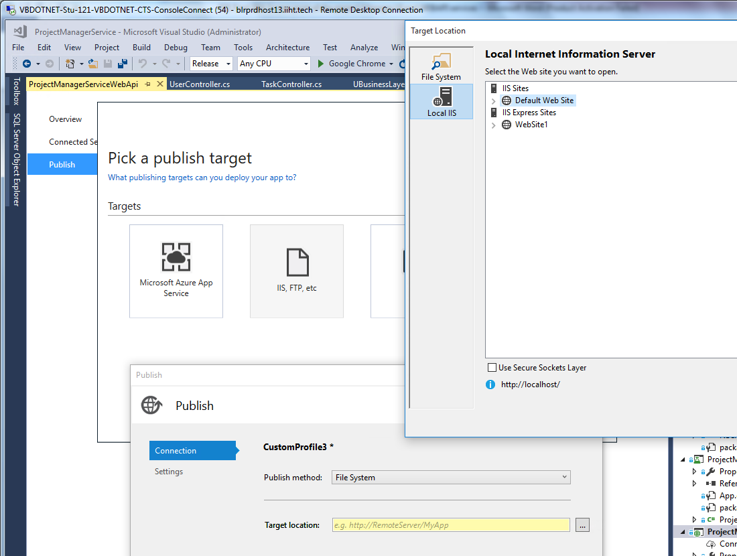

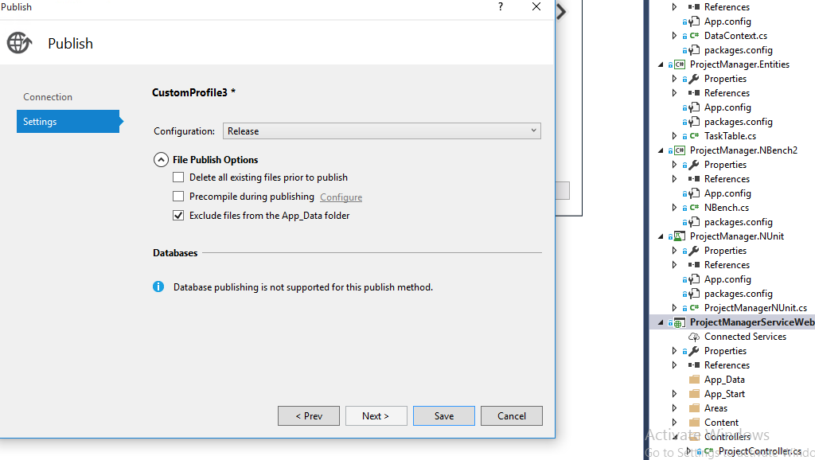

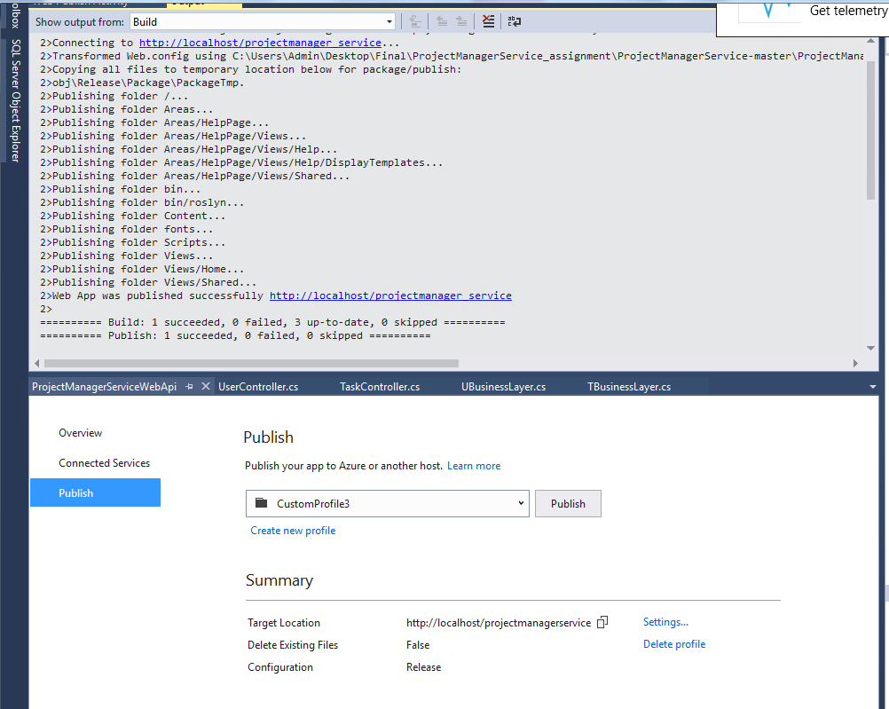

Hosting in IIS

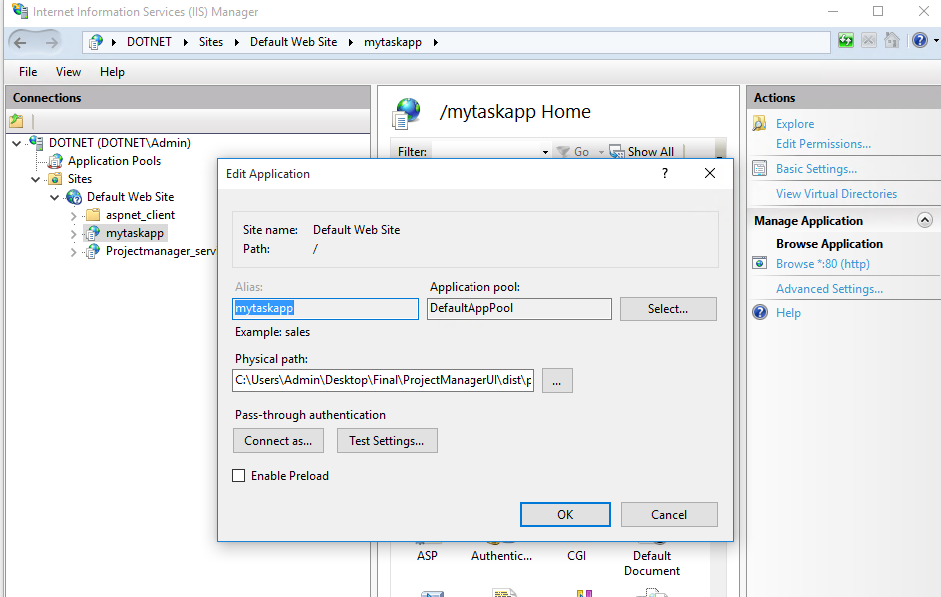

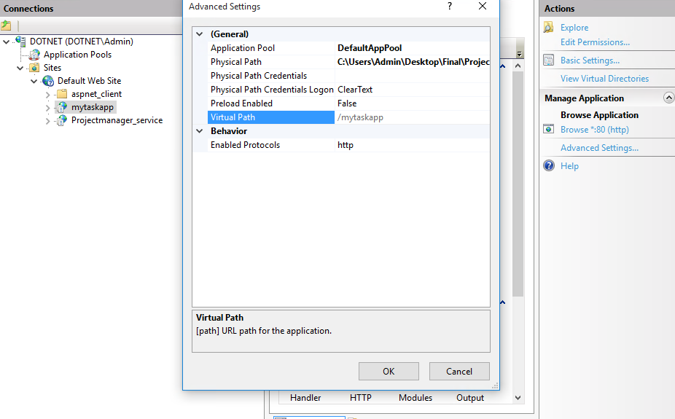

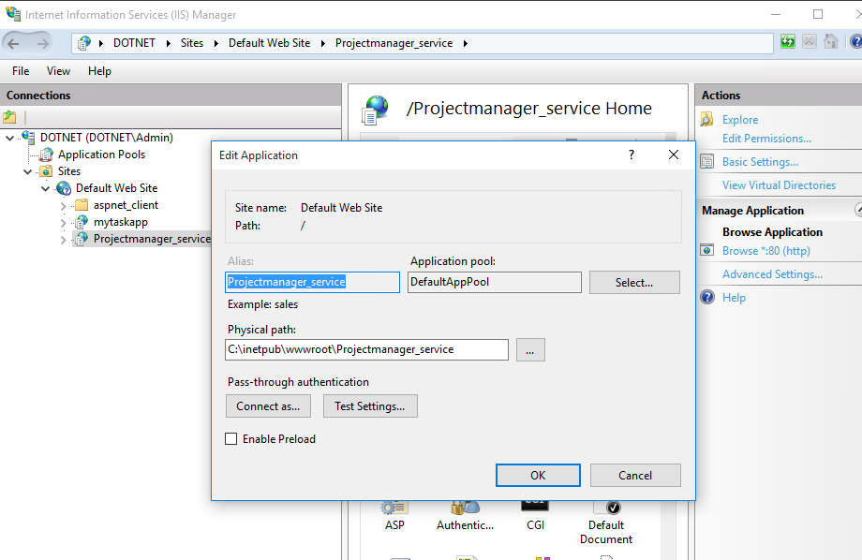

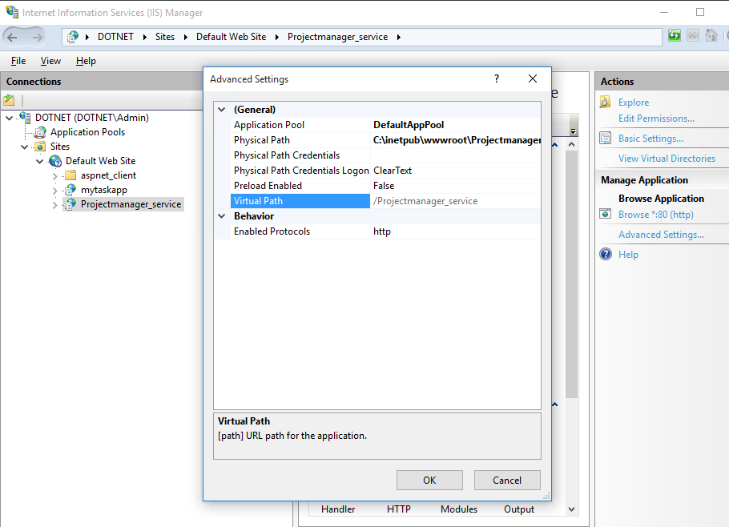

OutPut:

Getproject Summary:

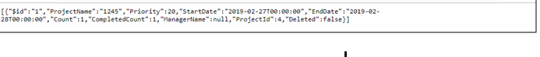

Getallprojects:

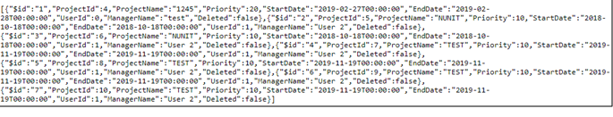

Getalltask:

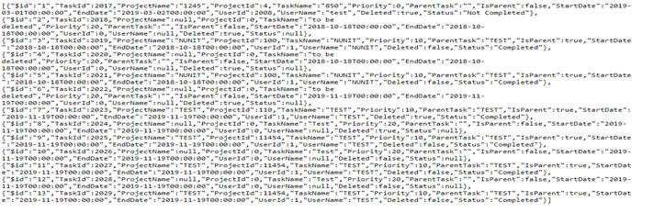

Getallusers:

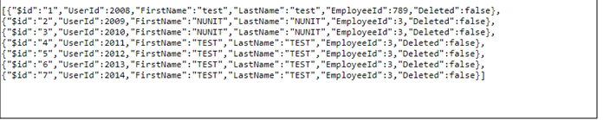

Getallsummary:

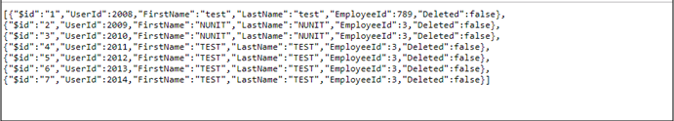

**Addproject:**

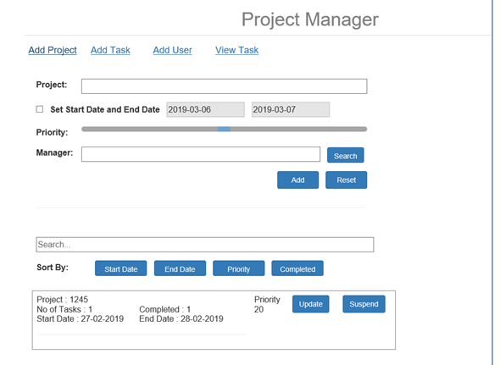

Update:

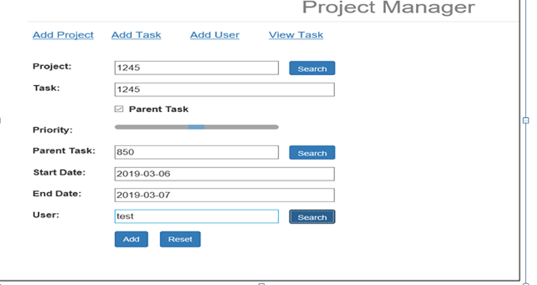

**View:**

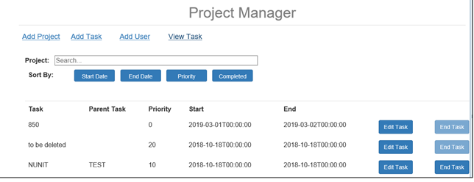

**Update:**

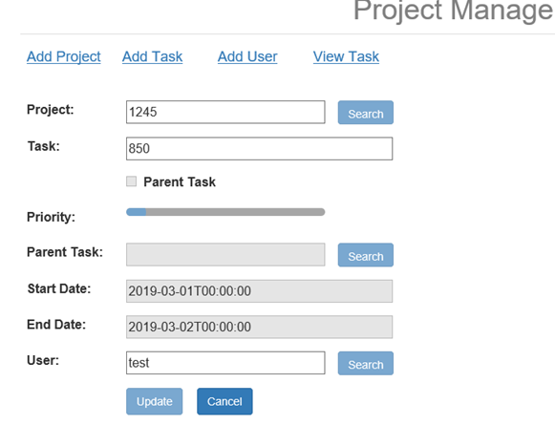

**Sort by:**



**Search:**



**Deployed Angular code to Git:**













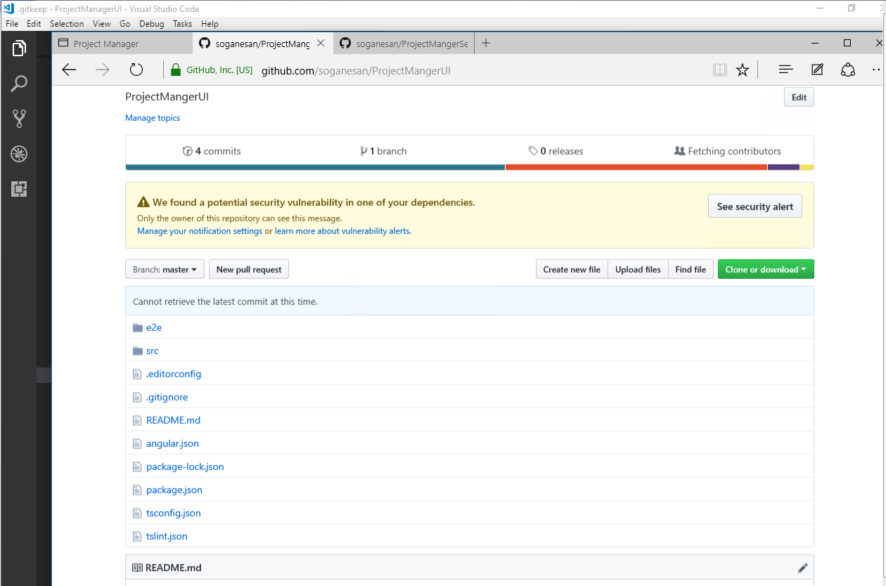

**Deployed Visual studio code to GIT:**













